Best Regards,

Sean Hsieh
Bortly Neon Corp. USA
www.NrNeon.com

Attachments Preview:
3 out of 4 attachment(s)

Espresso 1 (20x12).jpg
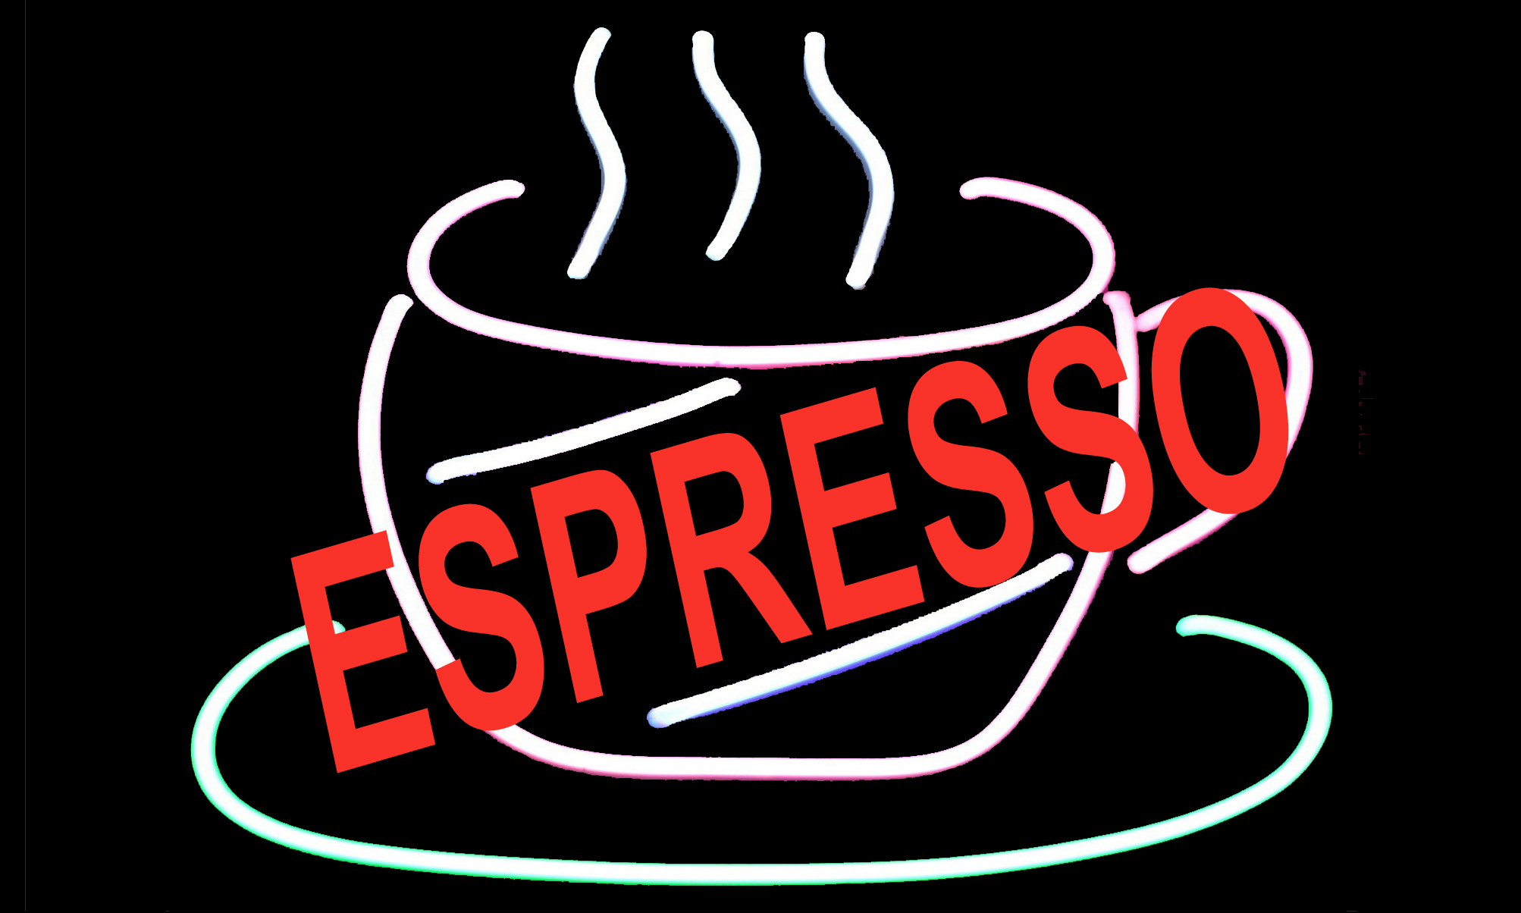

Espresso 2 (20x12).jpg


Espresso 3 (20x12).jpg


